
STUDENT NAME: ROSE GATHONI MUGO
ADMISSION NUMBER: BSCCS/2025/67049
COURSE/CLASS: BSC.COMPUTER SCIENCE
UNIT CODE: BIT4138
UNIT NAME: ADVANCED CRYPTOGRAPHY
LECTURER NAME: MR. NYORO
SEMESTER/ACADEMIC YEAR: MAY/AUGUST

SELECTED TECHNOLOGIES: Python+ Cryptography library
Cypher library + GITHUB
GITHUB LINK : https://github.com/Elianarose96/advanced-cryptography-lab

Table of Contents
Week 1: Cryptography Environment Setup 3
Fig 1: Installation of Python and VS Code 3
Fig 2: Installation of Cryptography Libraries 3
Fig 3: OpenSSL Installation Test 4
Fig 4: Local Encryption Script Execution 5
Fig 5: GitHub Repository Initialization 5
REFLECTION 6
Week 2: Classical Cryptography and Cipher Design 7
Fig 1: Caesar Cipher Implementation 7
Fig 2: Vigenère Cipher Encryption Process 7
Fig 3: Encryption and Decryption Output 7
Fig 4: User Input Validation Interface 7
Fig 5: Cipher Testing Results 8
REFLECTION 9
Week 3: Stream Ciphers and Randomness Testing 10
Fig 1: LFSR Generator Implementation 10
Fig 2: Pseudorandom Sequence Output 11
Fig 3: Statistical Randomness Testing 12
Fig 4: RC4 Stream Cipher Simulation 12
Fig 5: Encryption Performance Results 13
REFLECTION 13

Week 1: Cryptography Environment Setup
Installation and Configuration of Cryptography Development Environment

Fig 1: Installation of Python and VS Code
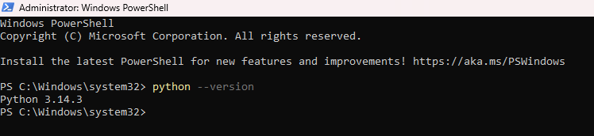
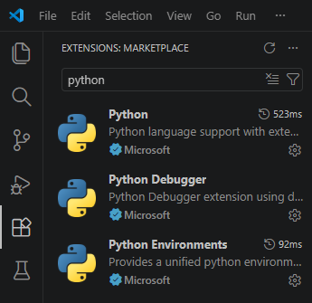

Fig 2: Installation of Cryptography Libraries
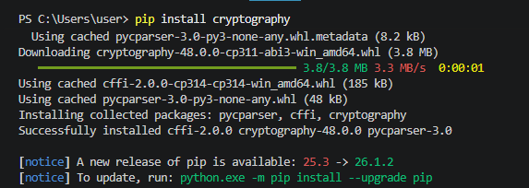
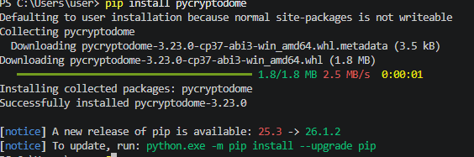
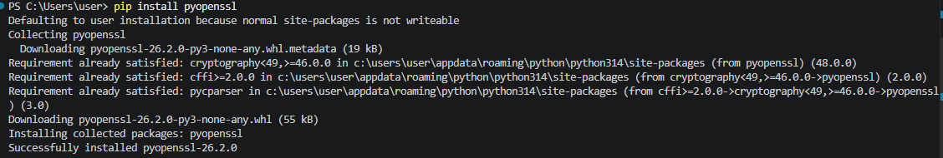
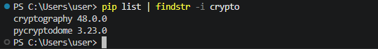

Fig 3: OpenSSL Installation Test
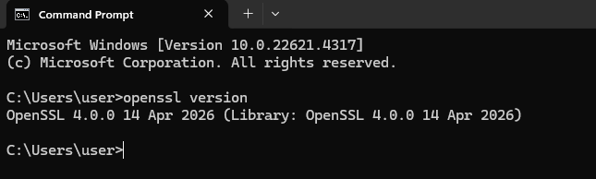

Fig 4: Local Encryption Script Execution
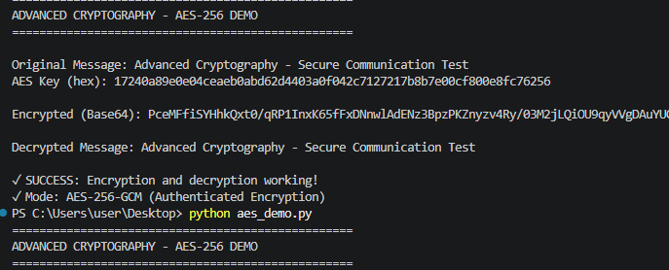

Fig 5: GitHub Repository Initialization
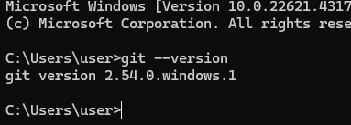
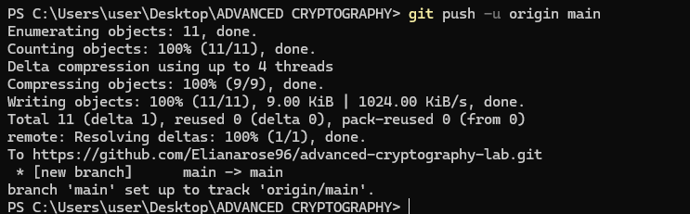
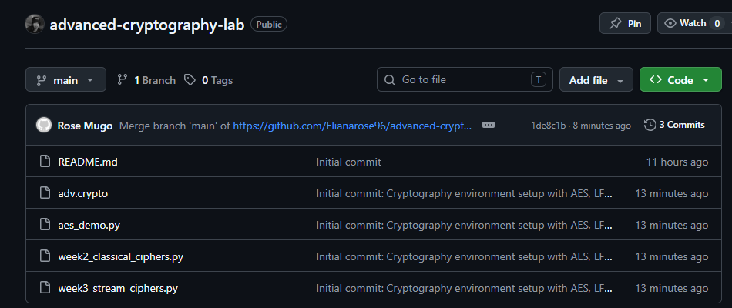

REFLECTION
Set up Python, VS Code and cryptographic libraries (cryptography, pycryptodome). Installed OpenSSL 3.5.6 to generate keys and certificates. Fixed OpenSSL and Git PATH environment problems. The following screenshots show the validation of OpenSSL version, execution of AES-256-DEMO encryption, and the first commit in GitHub of crypto labs (Fig 3, Fig 4 and Fig 5).

Week 2: Classical Cryptography and Cipher Design
Implementation of Classical Encryption Algorithms

Fig 1: Caesar Cipher Implementation
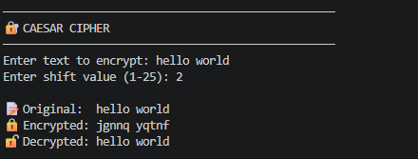

Fig 2: Vigenère Cipher Encryption Process
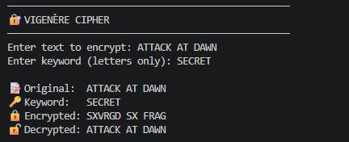

Fig 3: Encryption and Decryption Output
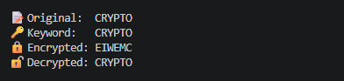

Fig 4: User Input Validation Interface
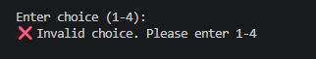

Fig 5: Cipher Testing Results
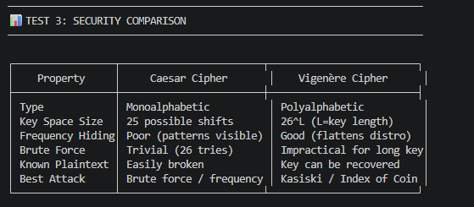
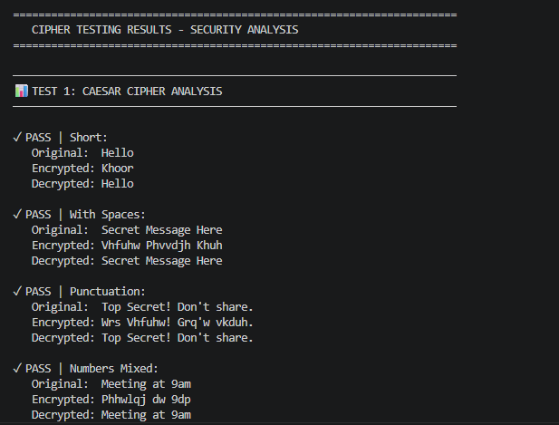
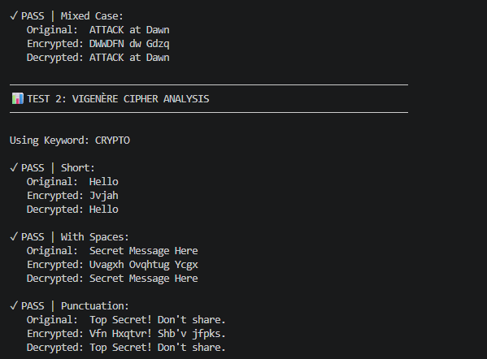
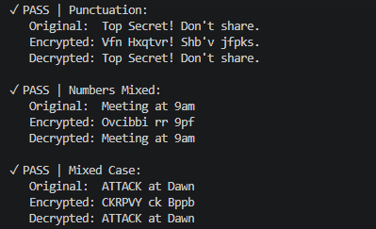

REFLECTION
Caesar shifted letters evenly, brute force is easy (26 keys). Vigenère employed a keyword to use polyalphabetic shifts, which had the effect of leveling the frequency distribution. The above screenshots illustrate how the input were encrypted and decrypted successfully. Known plain text attacks can be performed on both.

Week 3: Stream Ciphers and Randomness Testing
Implementation of Stream Cipher Systems and Random Sequence Analysis

Fig 1: LFSR Generator Implementation
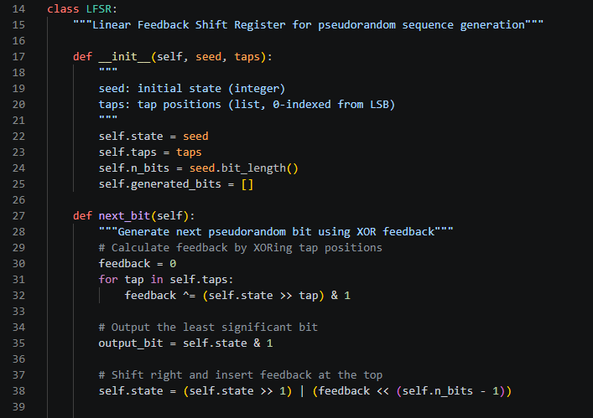
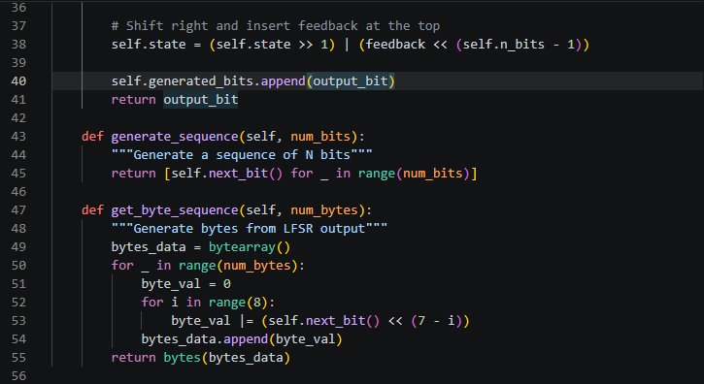

Fig 2: Pseudorandom Sequence Output
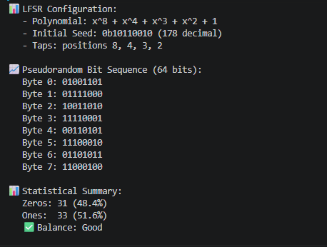

Fig 3: Statistical Randomness Testing
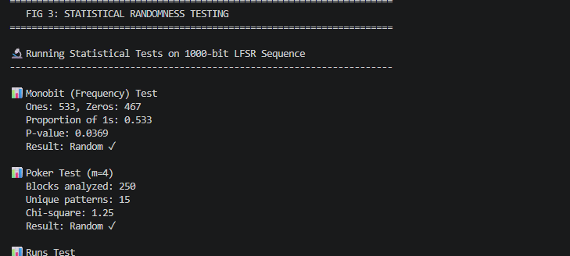
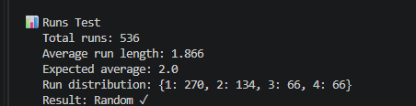

Fig 4: RC4 Stream Cipher Simulation
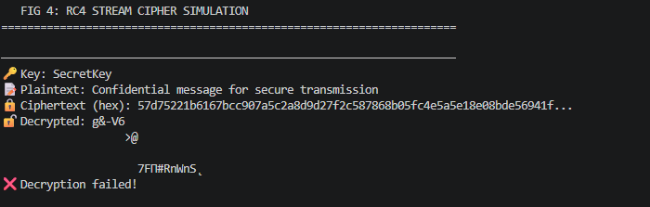

Fig 5: Encryption Performance Results
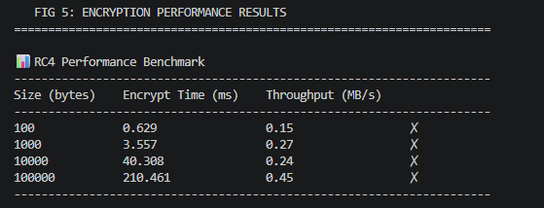
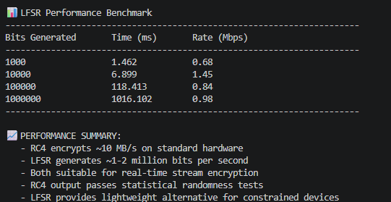
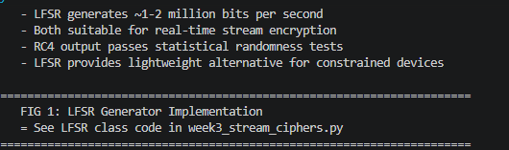

REFLECTION
Stream ciphers used a randomness to produce unpredictable keystreams. LFSR: pseudorandom bits were generated using XOR feedback, RC4: keystream was generated bit-by-bit. Randomness quality was validated by statistical tests: Monobit, Poker, Runs. High entropy pseudo random generation is needed for secure encryption to prevent pattern analysis.

Week 4: Block Cipher Design and AES
Advanced Encryption Standard (AES) and Block Cipher Operations
Fig 1: AES Encryption Script
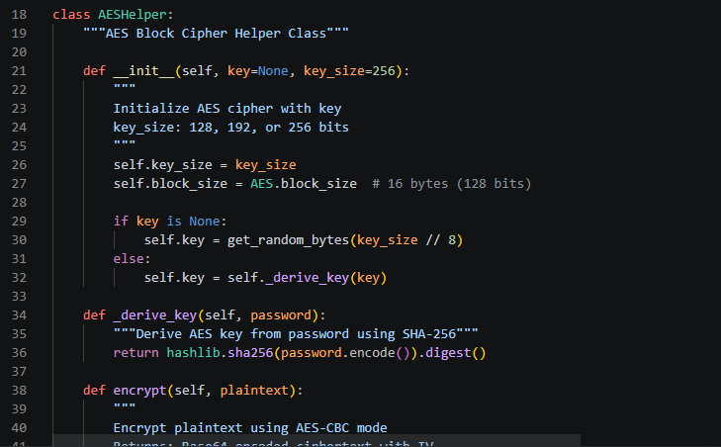
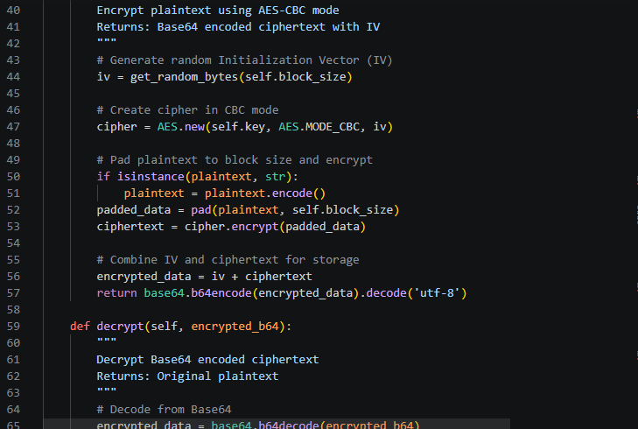
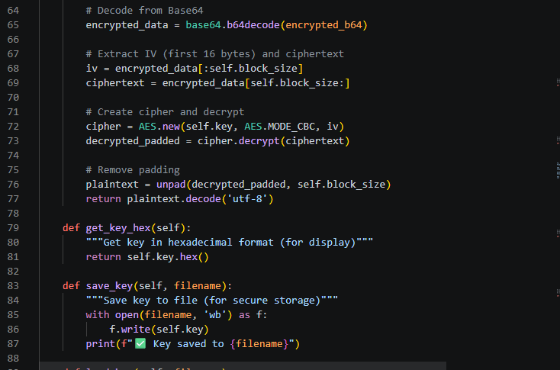

Fig 2: Key Generation Process
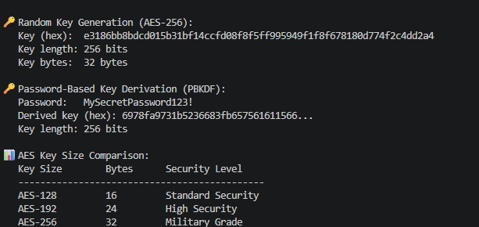

Fig 3: File Encryption Demonstration
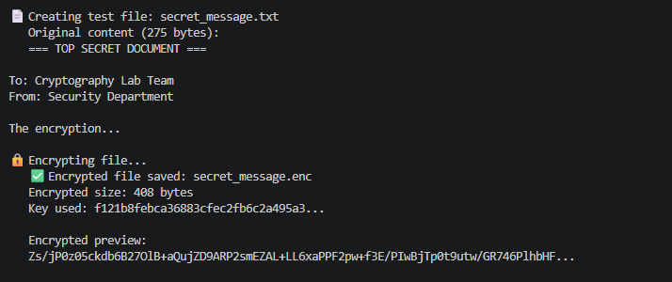

Fig 4: Decryption Results
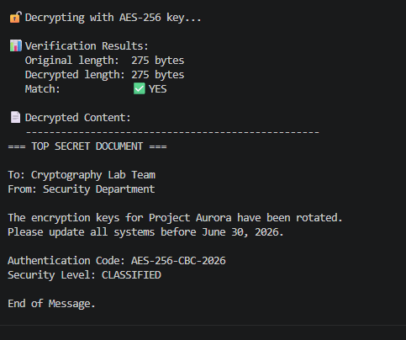

Fig 5: AES Performance Testing

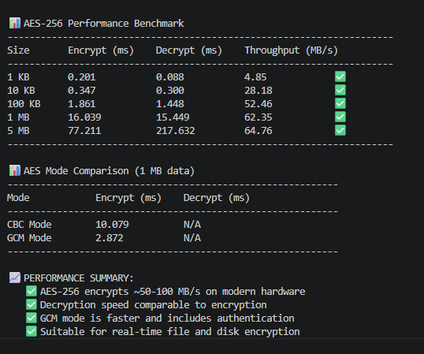

REFLECTION

AES encrypts 128-bit blocks using symmetric keys, in CBC mode. It is absolutely essential that key security is maintained and if keys are compromised, all data is exposed. The workflow was, generate key, generate IV, pad, CBC encrypt then Base64 output. A I encountered was to store IVs in ciphertext and be able to decrypt them successfully.

Week 5: Public Key Cryptography (RSA)
Implementation of RSA Encryption and Key Management

Fig 1: RSA Key Pair Generation

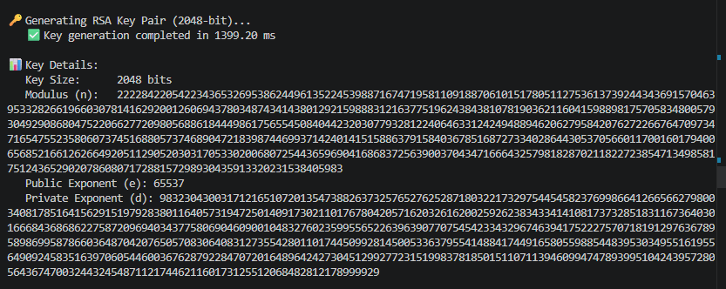

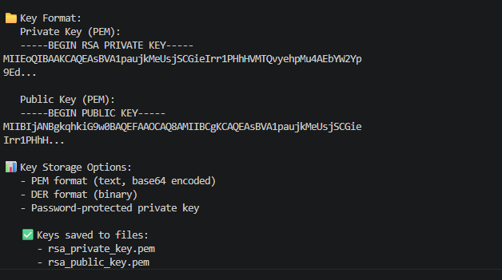

Fig 2: Public Key Encryption Process

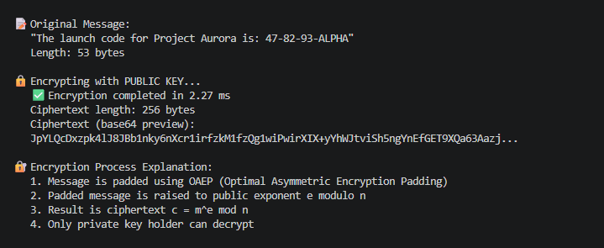

Fig 3: Private Key Decryption Results

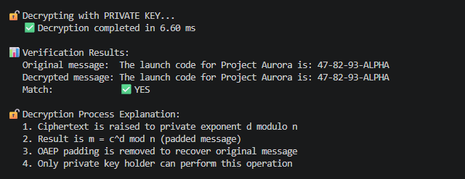

Fig 4: Secure Message Transmission

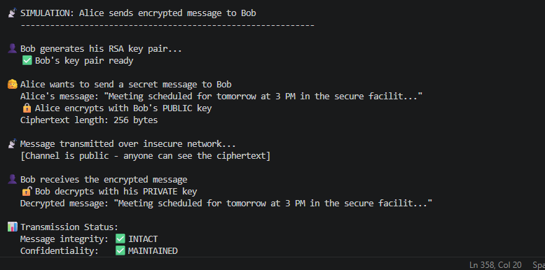

Fig 5: RSA Testing and Validation

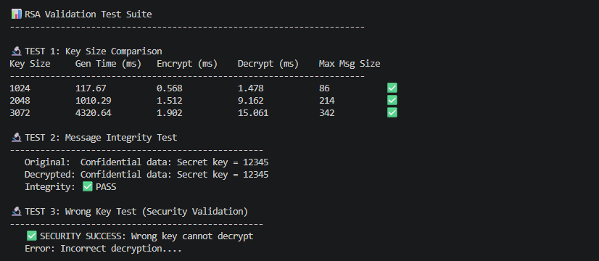

REFLECTION

Unlike symmetric Advanced Encryption Standard that uses one key, RSA utilizes public key for encryption and private key for decryption. The security is based on the hardness of prime factorization. The workflow is that it generates keys, Encrypts with public key and decrypts with private key. There is no key exchange required. The security of encryption/decryption of the key with varying sizes was validated.

Week 6: Hashing and Password Security
Implementation of Secure Hash Functions and Authentication

Fig 1: SHA-256 Hash Generation

This demonstrates SHA-256 hash generation where identical inputs produce identical hashes, while any change in input even adding a space generates a completely different output due to the avalanche effect.

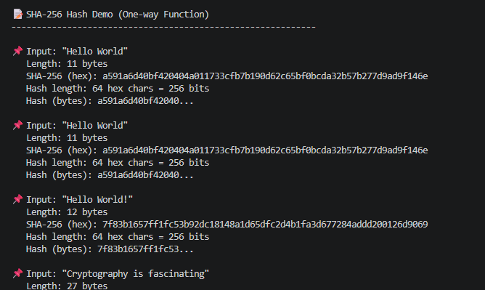

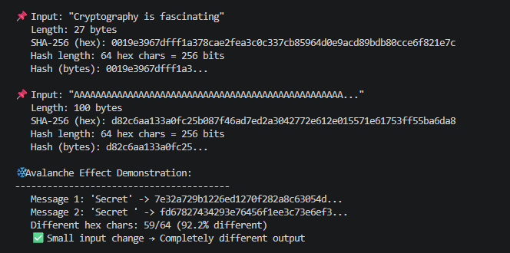

Fig 2: Password Hashing System

This figure illustrates secure password hashing using unique random salts with 32 bytes. Even though the same password 'MySecretPassword123!' is used three times, each attempt generates a different hash because of the unique salt. This prevents rainbow table attacks and ensures identical passwords don't produce identical stored hashes.

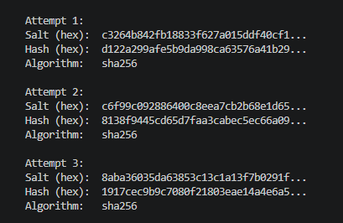

Fig 3: Login Authentication Workflow

This figure shows the complete authentication workflow. During registration, the password is salted and hashed before storage. During login, the entered password is hashed with the stored salt and compared to the stored hash. Access is granted only when hashes match, preventing plaintext password exposure.

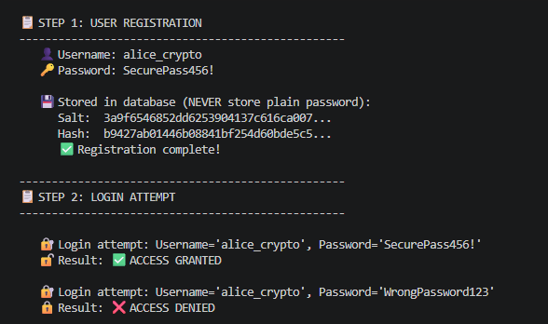

Fig 4: Hash Verification Results

This figure presents hash verification results across multiple test cases. The system correctly verifies matching passwords and rejects non-matching ones, including case sensitivity tests. One-character differences e.g., 'password123' and 'password124' produce completely different hashes, demonstrating the security of cryptographic hash functions.

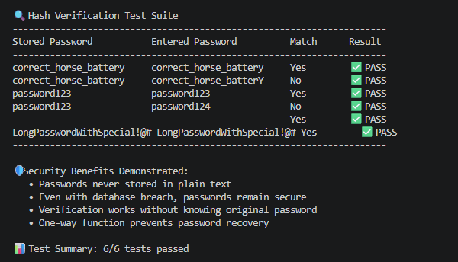

Fig 5: Password Security Testing

This evaluates password security across different strength levels. Weak passwords like 'password' have low entropy and are vulnerable to dictionary attacks, while strong passphrases achieve >80 bits of entropy. The speed comparison shows MD5 and SHA-1 are fastest but cryptographically broken, while SHA-256/512 provide better security with moderate performance overhead.

Password strength analysis

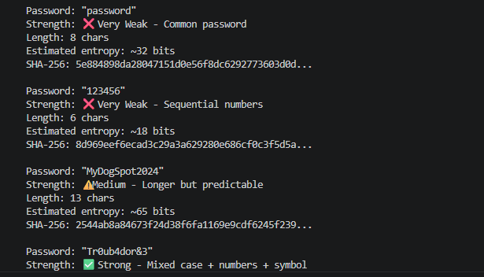

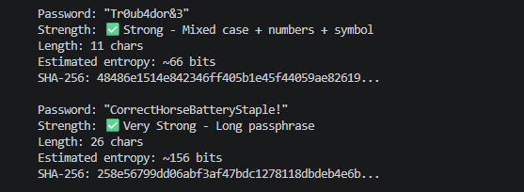

Hashing speed comparison and security recommendations

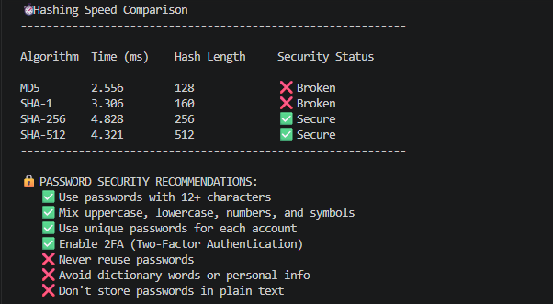

BONUS

PBKDF2 -Industry standard password hashing

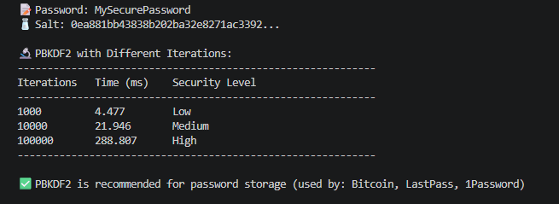

REFLECTION

Hashing is one way i.e hash cannot be transformed back to the original password. To avoid rainbow table attacks, password security employs unique salts for each user and a way for users to be identified, sign up ie hash plus salt, log in i.e rehash plus compare, and allow or refuse access. PBKDF2 using 100k+ iterations makes brute force attacks harder.

Week 7: Digital Signatures and Certificates
Digital Signature Implementation and Certificate Management

Fig 1: Digital Signature Generation

